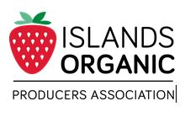
______________________________________________________________________

Date:

I, _________________________________________________ am a contractor of __________________ [IOPA farmer].

I agree to act consistently with the IOPA guidelines and the Canadian
Organic Standards when working in the organic growing area.

I agree that any equipment brought onto the organic farm has been
thoroughly cleaned of any/all non-organic substances, as per the Permitted
Substances List, prior to commencing work.

Additional comments:

___________________________________
Signature(s)

___________________________________
Printed Name(s)

Phone number: ____________________________

Address: __________________________________
__________________________________
__________________________________

