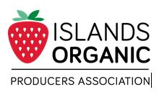

Input form: Seeds

On ______________ [date] ________________________ [name of IOPA farmer] received________ [quantity] of _____________ seeds.

These seeds (check boxes which apply):
- are Certified Organic List CO number_____________;
- have not been treated with herbicides or pesticides;
- have not come into contact with pressure treated wood;
- are non-GMO
- are untreated

Additional comments:

___________________________________

Signature of supplier

___________________________________
Printed Name of supplier

Phone number: ____________________________

Address: __________________________________

The purpose of this form is to help organic producers assess the appropriateness of various inputs and to meet audit trail requirements of the COABC standards. Whenever possible, certified organic or OMRI-approved inputs should be used. Written documentation is required for inputs brought onto organic farms. Filling out this form does not make a particular input acceptable. Please see the IOPA guidelines and COABC standards for the rules regarding inputs.

