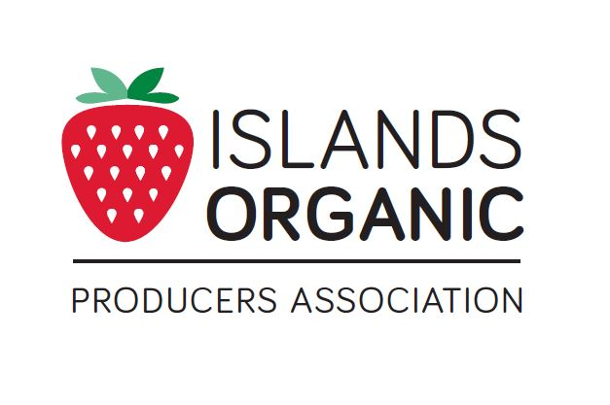**2021**

**COVID-19**

**REMOTE INSPECTION POLICY**

Islands Organic Producers Association (IOPA)



IOPA Administrative Director:

Crystal Arsenault

admin@iopa.ca

250 858-5239

3612 Rosedale Rd

Duncan BC, V9L 6N1

[www.iopa.ca](http://www.iopa.ca)

**Introduction:**

This policy has been developed in response to the 2020 Pandemic, COVID – 19. Travel restrictions and social distancing have been imposed by the Government of Canada, beginning in March 2020. As such, IOPA cannot lawfully instruct Verification Officers (VO’s) to physically visit Operations, nor can IOPA instruct operators to accept off-site inspectors onto their properties. The inability to satisfy the on-site inspections requirement of the BCCOP Standards has led to the development of the following Remote Inspection Assessment and Protocols.

**Instructions to Members:**

IOPA has created a remote inspection assessment and policy to fulfill on-site inspection requirements until further notice. We will continue to remotely inspect as many operations as possible until social distancing and travel restrictions are lifted by the Government, at which time we will resume on-site inspections.

If your operation has been selected for remote inspection assessment, you will be contacted by a verification officer directly. Please try to respond quickly when an inspector reaches out to you to discuss remote inspection.

**Of special note:**

New operations will require a full on-site inspection prior to being eligible for transition to organic.

Additions to scope of certification, addition of new production sites or other major changes may require an on-site visit.

Low-risk operations due for an inspection require an on-site visit.

Fully virtual inspections are not allowed 2 years in a row, so operations who were remote inspected last year, will be scheduled for an on-site visit later in the season, when restrictions are expected to be lifted.

On site visits will follow provincial guidelines for social distancing, personal protection equipment and hygiene.

**Step 1: Initial Contact**

In this initial assessment, you will be asked several assessment questions in order to determine if your operation is a good candidate for remote inspection. If you have any concerns, this preliminary meeting is a good opportunity to discuss them with the inspector.

Your recordkeeping system, production activities, and technical tools will be discussed.

If, during the initial contact, it is determined that your operation is not a good fit for remote inspection, the verification officer will inform IOPA and you will be scheduled for an on-site inspection as soon as restrictions are lifted.

If your operation is determined to be a good fit for remote inspection, next steps will be:

* The inspector will identify the specific records you must submit to verify your business’ compliance since your last on-site inspection.
* Due dates for submitting records will be established.
* You should expect some potential back and forth phone/email discussion regarding the documents you submit, with the possibility of being asked to submit additional documents as needed.

Please do your best to respond in a timely fashion to requests from your inspector, in order to ensure a smooth and timely process.

**Step 2: Remote Inspection Interview/tour**

After the inspector has had a chance to review the files you submit, you will be contacted to arrange for a remote inspection interview, with the potential requirement of a remote, visual walk around/tour of your operation.

Please try to organize your records so you are ready to discuss them with the inspector and you can easily share your records when requested. During this scheduled interview, traceback and volume audits will be performed. Please have all paperwork ready and accessible.

Ensure knowledgeable staff are available to answer questions about all organic production and handling activities. Discuss any key absences with your inspector when scheduling meetings.

_____________________________________________________________________________

**VO Procedures:**

After receiving a file, the VO is instructed to contact the Operator via phone or email and discuss and report on the following topics. They may choose to send the following questions to the operation in advance of their call, and discuss the particulars together during the call.

**Remote Assessment Questionnaire**

**Section 1: Electronics**

1. How would you describe your comfort level with electronically sharing information?

Please select all items that you are comfortable with:

* + Share documents by uploading, scanning and attaching to email
  + take photos with smart phone and share them using text message
  + upload photos to a computer and attach to an email
  + allow inspector to view your computer using screen sharing
  + Take a video of specified areas of production, upload it to a file sharing program
  + Use Google Drive for google docs
  + Use Dropbox

1. Do you have video chat capabilities such as:
   * Facetime,
   * Skype,
   * Zoom or
   * other streaming video capabilities. please list_______________

If no, would you be comfortable accessing and using Zoom with guidance?

* + Can you access streaming video on a mobile device like a phone or laptop that can connect to the internet for a remote inspection walk around/tour of your operation?
  + Do you have good cell/internet service in all areas of your operation?

1. Please be aware that you may be subject to additional charges by your internet/mobile service provider when accessing various areas of your operation. Are these potential charges a concern to you?

**Section 2: Inspection Time and Audit Records**

Remote inspection may take more time than an average on-site inspection, possibly up to 50% more time. Duration will depend on the amount of information you are able to provide ahead of time to your inspector and the amount of back-and-forth communication needed to satisfy inspector requirements.

For example, if you are able to provide photographic evidence of commonly required inspection information in clear photographs, the inspector will be able to perform much of the inspection prior to your scheduled remote inspection time, which will greatly reduce the amount of time needed using streaming video.

During remote inspection interview, you will need to provide information requested for audit compliance. Please review the following list of items that you will be required to show to the inspector.

Volume Audit information

The inspector will choose 1-2 crops in order to perform the volume audit.

You will need to provide documentation such as photos of seeding log books, pick sheets, invoices etc. for:

* quantity planted and location
* amount harvested and
* amount sold.

Traceback Audit information

The inspector will choose 1-2 crops in order to perform the traceback audit.

You will need to provide documentation of:

* seed source,
* amount planted, locations and dates.
* Dates amendments were added and
* amendment source/product name (including compost/manure).
* Date and amounts harvested and sold.

Additional items, if not uploaded with your renewal

* commercial availability searches for items such as non-CO seeds.
* Declarations for inputs

If the operator is generally technologically comfortable and feels capable of providing evidence of compliance through photographs or video, the inspector will provide them with a checklist of items specific to their operation that are required, based on a review of their renewal and file history. This list will include any specific physical areas they would like photos or video footage of.

After reviewing submitted files, the inspector will schedule the Remote Inspection Interview with the operator. During the remote inspection interview, the inspector can ask for clarification on any items submitted, request the operator show additional documents using the live streaming camera, or request a walk around/tour of any areas of the operation.

During the remote inspection interview, the inspector may wish to view the site using a smart phone, streaming video. The inspector must make it clear to the operator that the inspector is in charge of the ‘tour’. Meaning, they need to instruct the operator to ‘turn left’, ‘go back and show me again’. Operator should prepare for a video tour by ideally, bringing their submitted site map, so as to orientate the inspector as they travel to different areas of the operation.

Inspector should ask if the tour can be recorded or if screenshots can be taken during the video tour. These may be included in the final report and the authorization to record these should be noted on the exit interview.

After the assigned VO has conducted the initial assessment, received requested documents and performed a remote inspection interview/tour, they are instructed to send an exit interview to the operation and to submit their report to IOPA as per normal.

In addition to the submitted report, they are instructed to state their determination regarding the effectiveness of the remote inspection, by indicating:

1. whether or not the operation was able to submit all requested documents
2. how evidence was collected/provided eg. Photos, premade video, live streaming
3. whether or not they were satisfied with their ability to view production areas and observe active on-site management compliance evidence via photos, videos, live streaming etc.
4. provide recommendations on whether or not the operation requires a follow-up on-site inspection when it is possible to do so.

Hybrid Inspections

CC will review inspector’s notes regarding effectiveness of inspection and whether an on-site follow up is recommended. If the CC determine a hybrid inspection is necessary, the CC will instruct the VO to schedule an on-site tour. This tour is expected to be of short duration and the inspector may conduct the walk around solo, with prior approval and guided instructions from the owner of the operation. VO will submit a report noting any inconsistencies with renewal and interview information provided and on-site observations.